**SYSTEM DESIGN CONCEPTS:**

1. REST API

1. Vertical scaling vs Horizontal

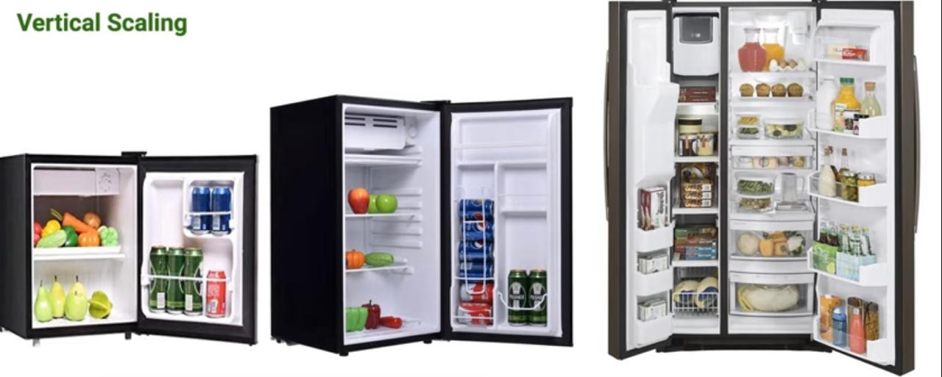

Horizontal Scaling

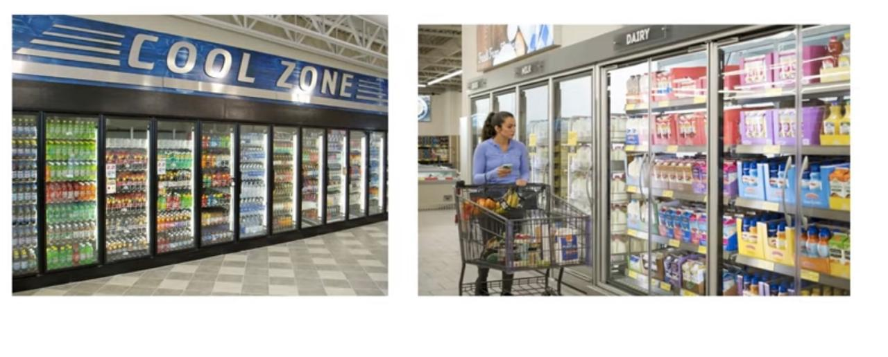

1. Polling vs Web Sockets vs SSE

Polling:

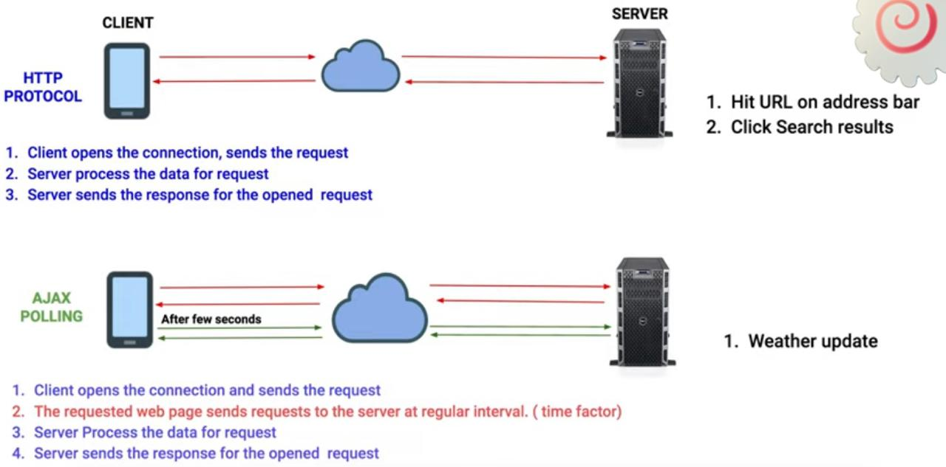

Web Sockets:

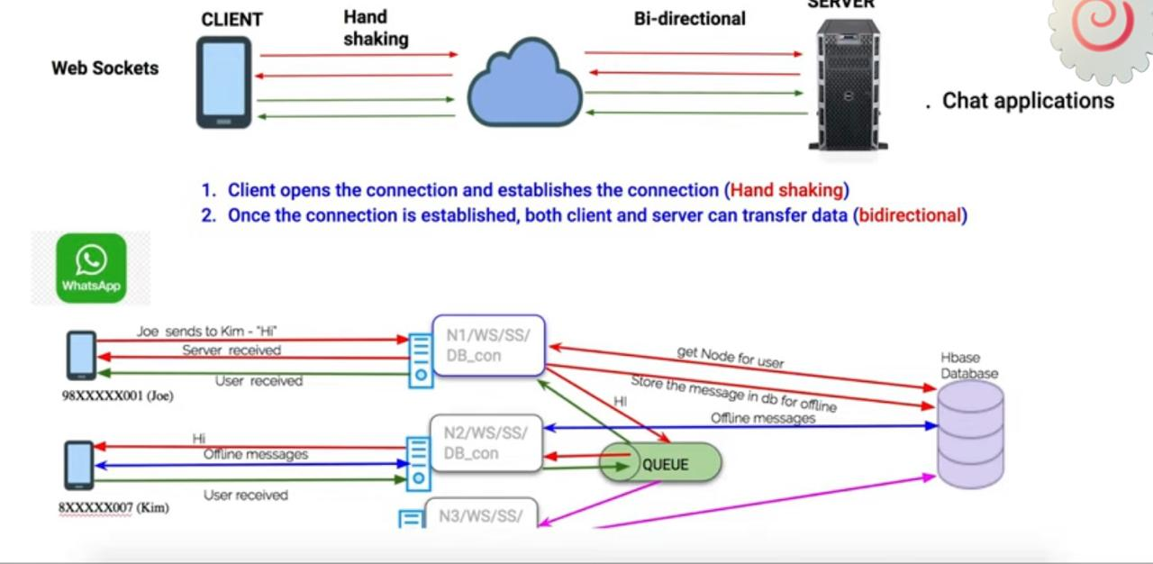

Server Side Events:

1. Sharding

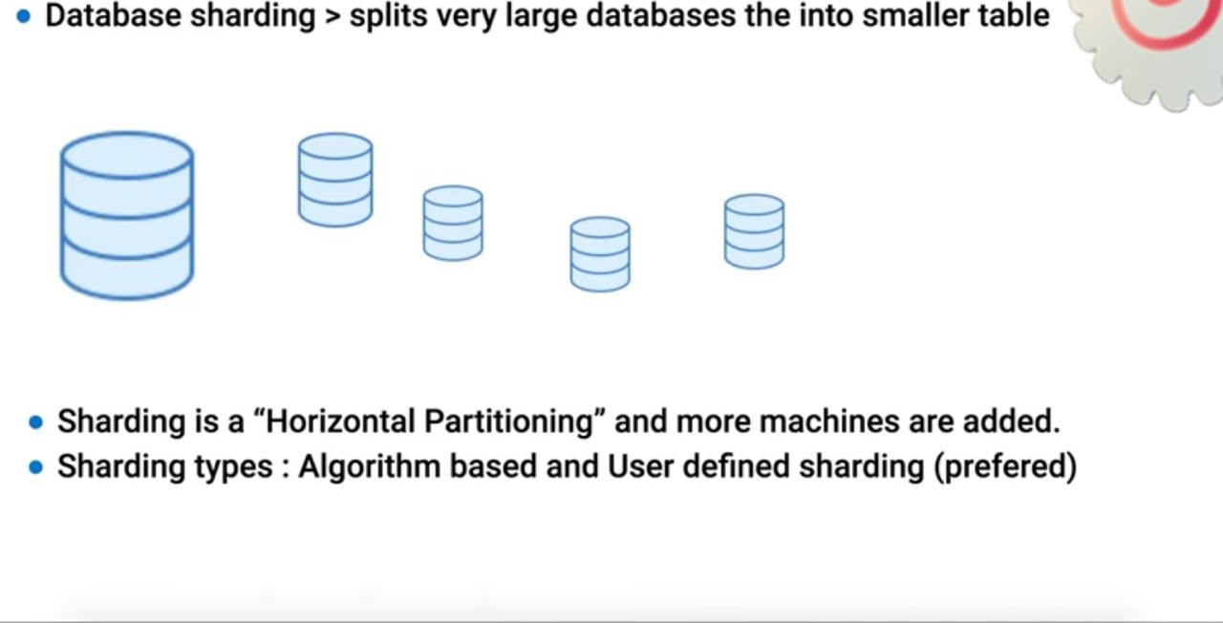

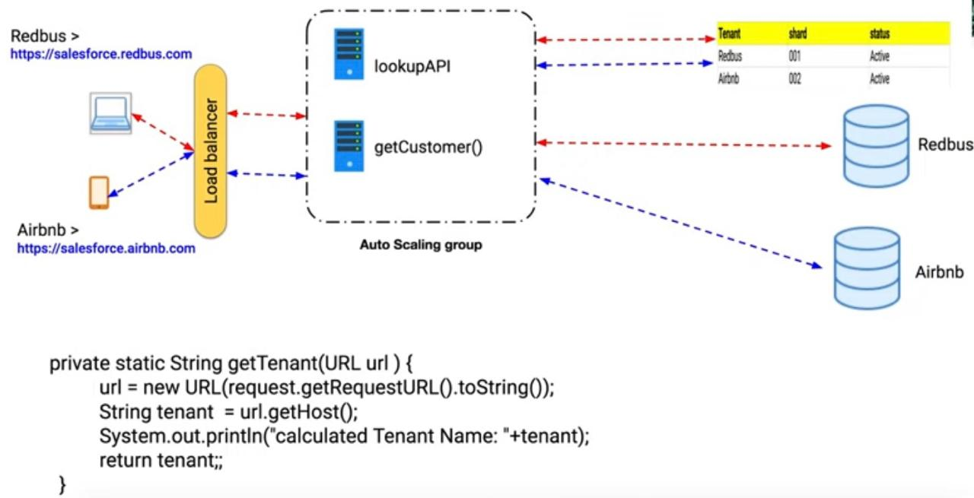

5.Service Discovery



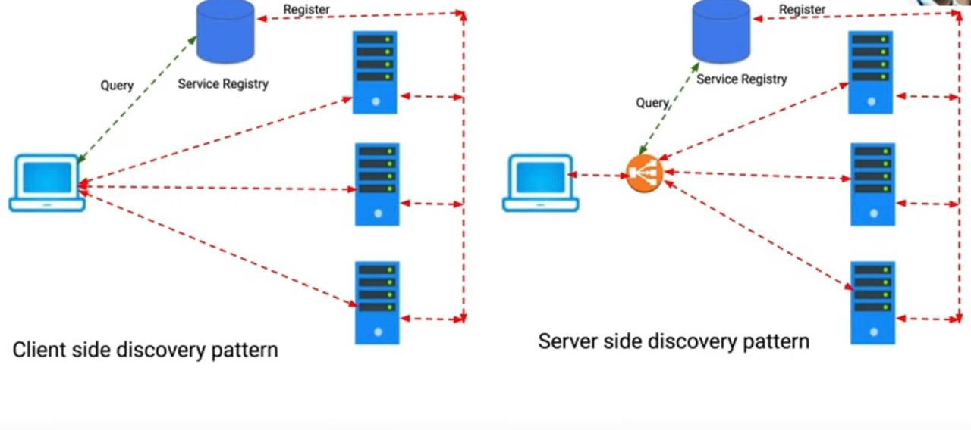

6.Multi Tenant:

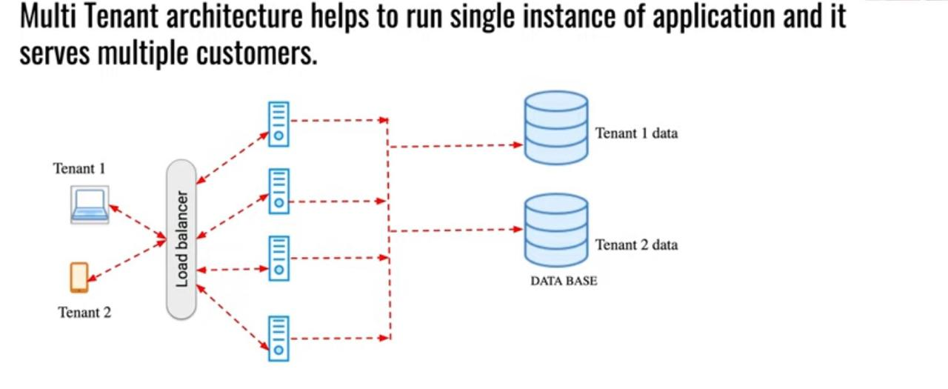

7.Distributed Transactions:

Traditional:

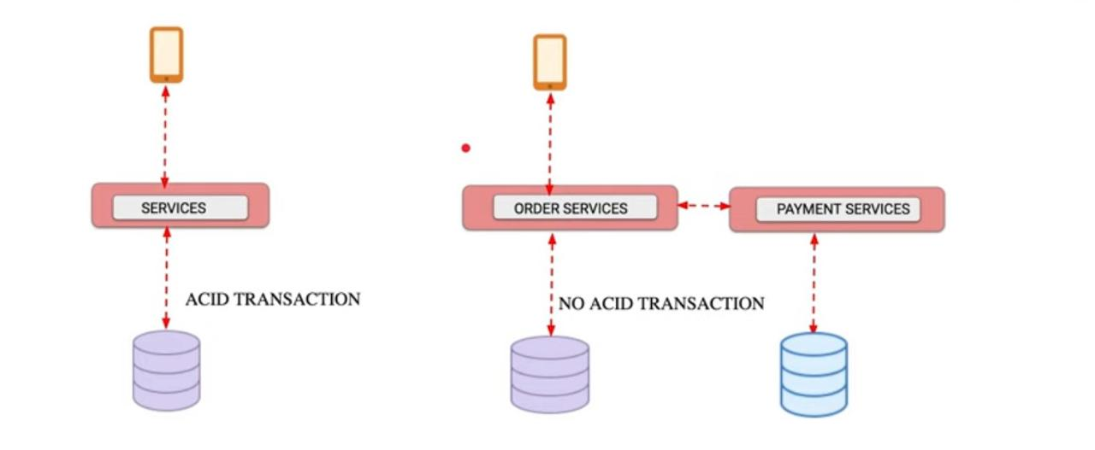

SAGA:

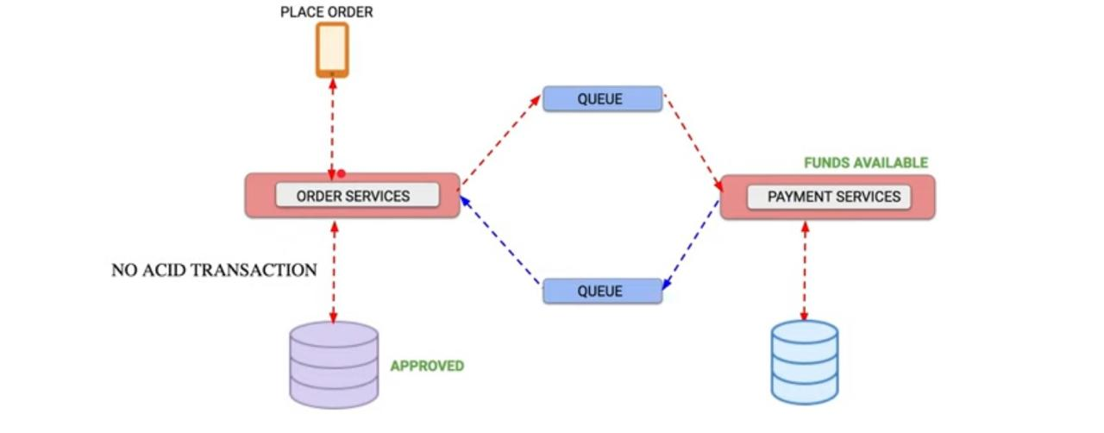

8.Circuit Breaker Pattern:

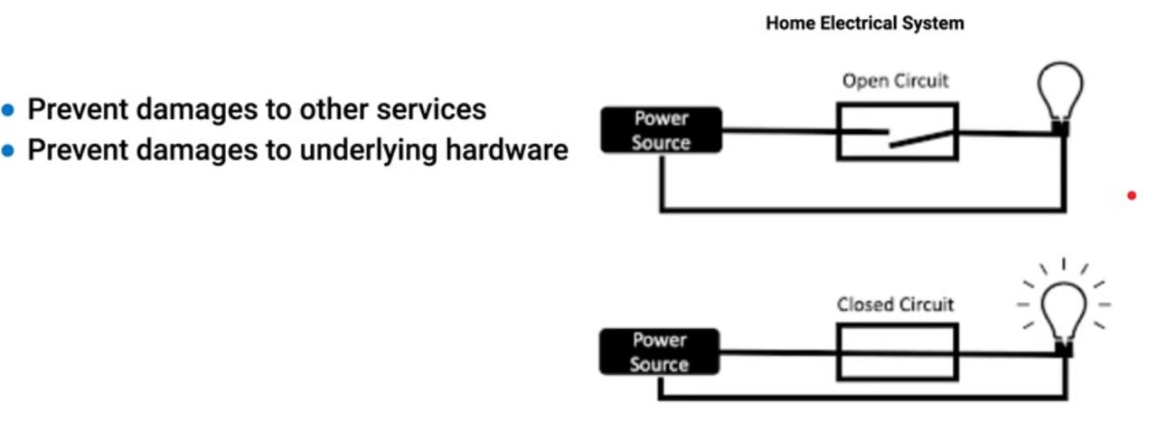

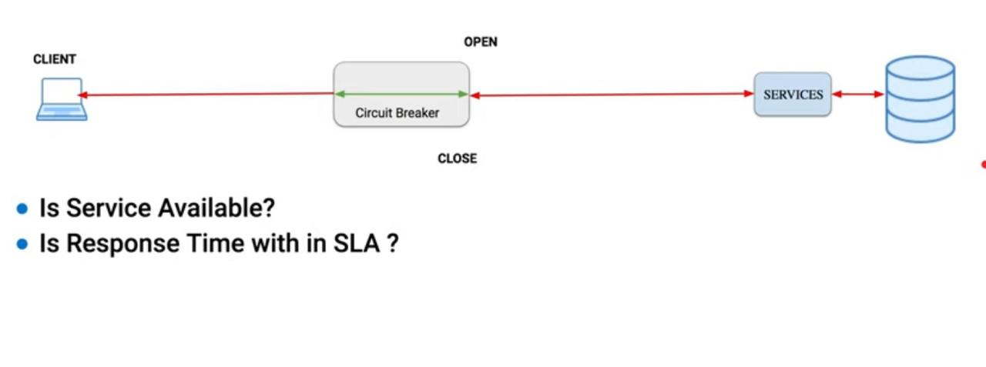

9. Application Gateway:

